**AWS Budgets**

**AWS Budgets**

In [**AWS Budgets**](https://aws.amazon.com/aws-cost-management/aws-budgets), you can create budgets to plan your service usage, service costs, and instance reservations.

The information in AWS Budgets updates three times a day. This helps you to accurately determine how close your usage is to your budgeted amounts or to the AWS Free Tier limits.

In AWS Budgets, you can also set custom alerts when your usage exceeds (or is forecasted to exceed) the budgeted amount.

**Example: AWS Budgets**

Suppose that you have set a budget for Amazon EC2. You want to ensure that your company’s usage of Amazon EC2 does not exceed $200 for the month.

In AWS Budgets, you could set a custom budget to notify you when your usage has reached half of this amount ($100). This setting would allow you to receive an alert and decide how you would like to proceed with your continued use of Amazon EC2.

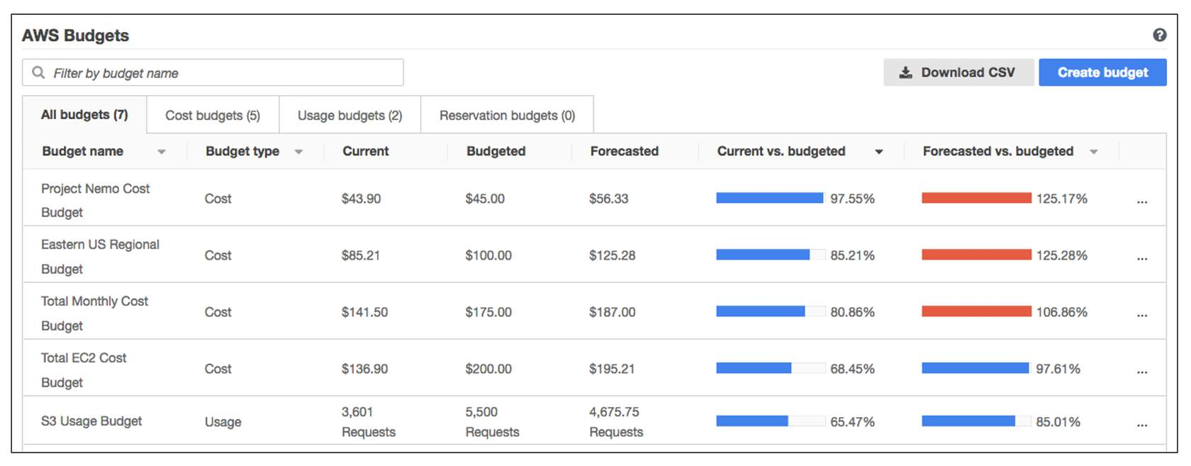

In this sample budget, you can review the following important details:

* The current amount that you have incurred for Amazon EC2 so far this month ($136.90)
* The amount that you are forecasted to spend for the month ($195.21), based on your usage patterns.

You can also review comparisons of your current vs. budgeted usage, and forecasted vs. budgeted usage.

For example, in the top row of this sample budget, the forecasted vs. budgeted bar is at 125.17%. The reason for the increase is that the forecasted amount ($56.33) exceeds the amount that had been budgeted for that item for the month ($45.00).